**SECURITY ALARM BASED ON PIR SENSOR**

Project report to

**Engr. FAIZULLAH** and **Dr SALMAN AHMAD**

For

**CSE-103** and **CSE-103L**

**Department of Computer Systems Engineering**

**UET Peshawar**



**Spring Semester 2021**

**PROJECT DONE BY:**

* Tameem ud din 20PWCSE1866
* M.Awais Khan 20PWCSE1871
* Ebtihaj Abdullah 20PWCSE1885

**PIR BASED ALARM:**

* A simple PIR sensor based alarm system works upon motion detection.
* It detects motion by monitoring fluctuations in surroundings IR radiations.

**WORKING PRINCIPLE:**

* When the PIR sensor detects a change in IR radiations, it sends a high current to BC 547 transistor which closes the buzzer circuit and a sound is produced. This circuit works on the same principle

**CIRCUIT SCHEMATICS:**

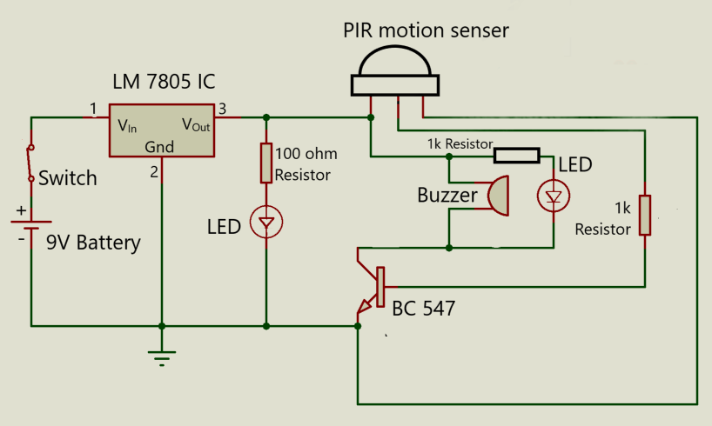

**MAIN COMPNENTS:**

The main components of this circuit are:

1. PIR Sensor:
2. Detects IR radiations.
3. Uses a Fresnel lens that focuses IR on a Pyroelectric sensor.
4. Pyroelectric sensor generates electric signal upon fluctuating IR radiation.
5. LM 7805 IC
6. Restricts output voltage to 5V for various ranges of input voltages.
7. BC 547
8. NPN transistor for quick switching.

**MEASUREMENTS:**

Following are the simulation measurements across the circuit:

**VOLTAGE MEASUREMENTS:**

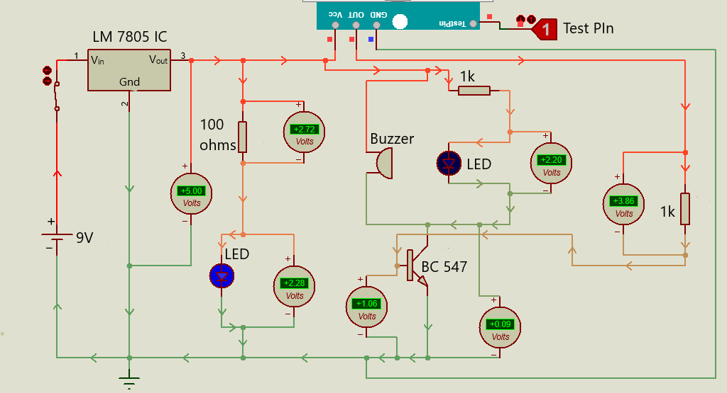

**CURRENT MEASUREMENT:**

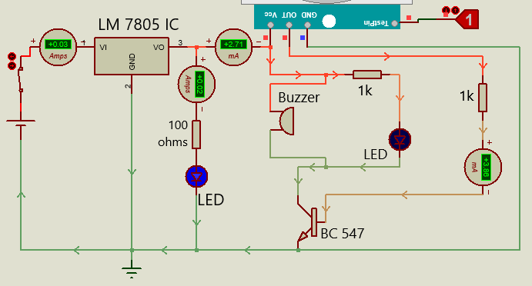

**COMPARING SIMULATION AND MANUAL VALUES:**

Taking manual measurements from the circuit using a **Digital Multimeter** and comparing them with simulation values:

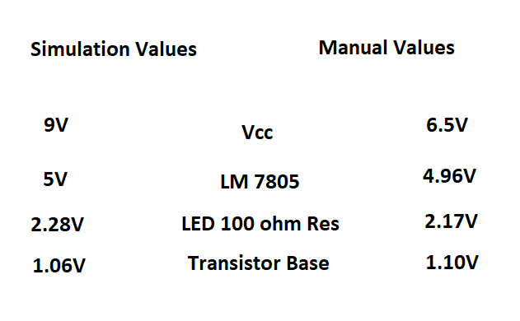

**APPLICATIONS OF PIR SECURITY ALARM SYSTEM:**

* This alarm system is used for security purposes.
* This alarm system detects any motion in its vicinity or surroundings.
* This alarm system can be used to detect intrusions in a specific area.
* It is mostly used in sensitive and classified buildings and places.
* Can be used for home security systems also.

**PRESENTATION:**

